Loading...

Loading...

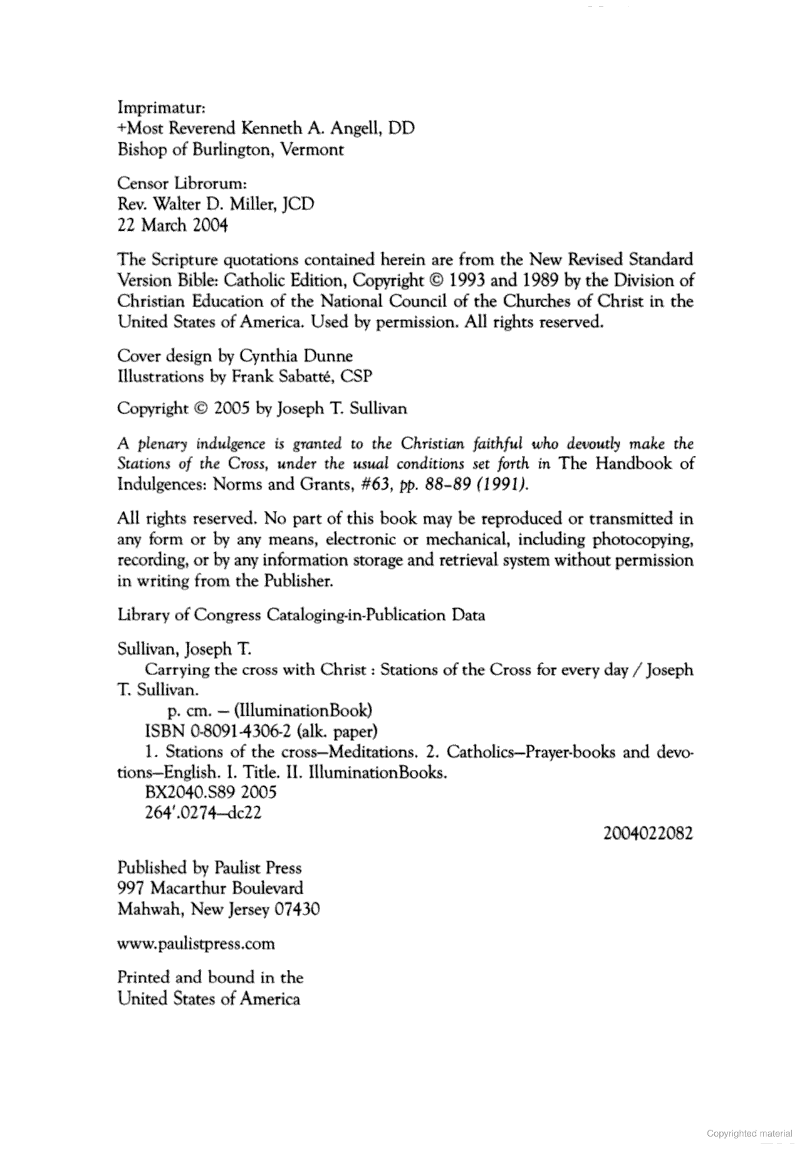

|  |  |
| --- | --- |
| |  | | --- | | Some pages are omitted from this book preview. | |

Loading...

Loading...

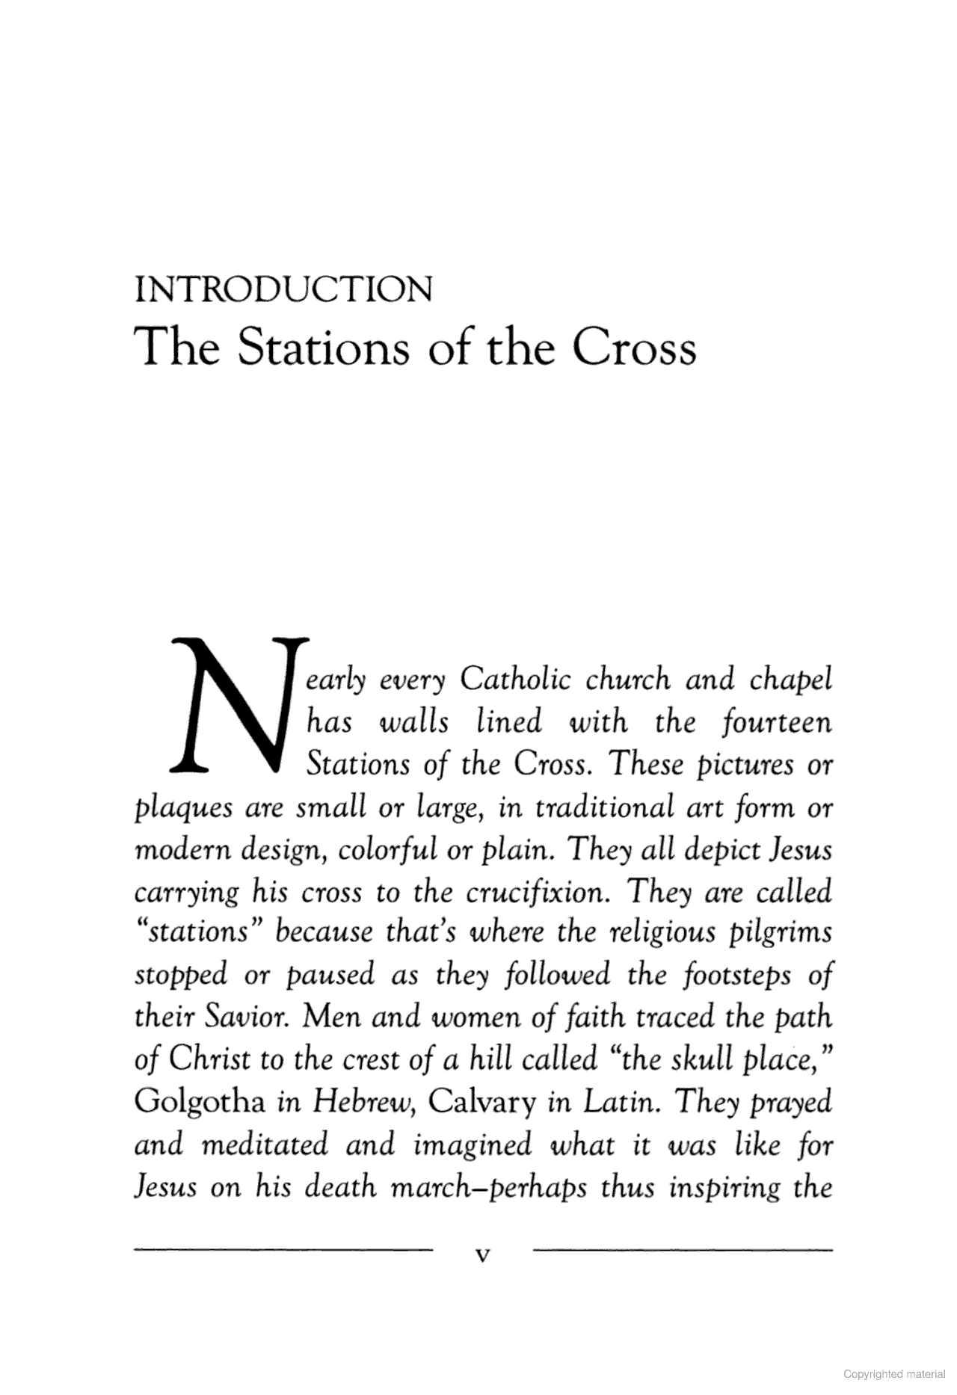

Loading...

Loading...

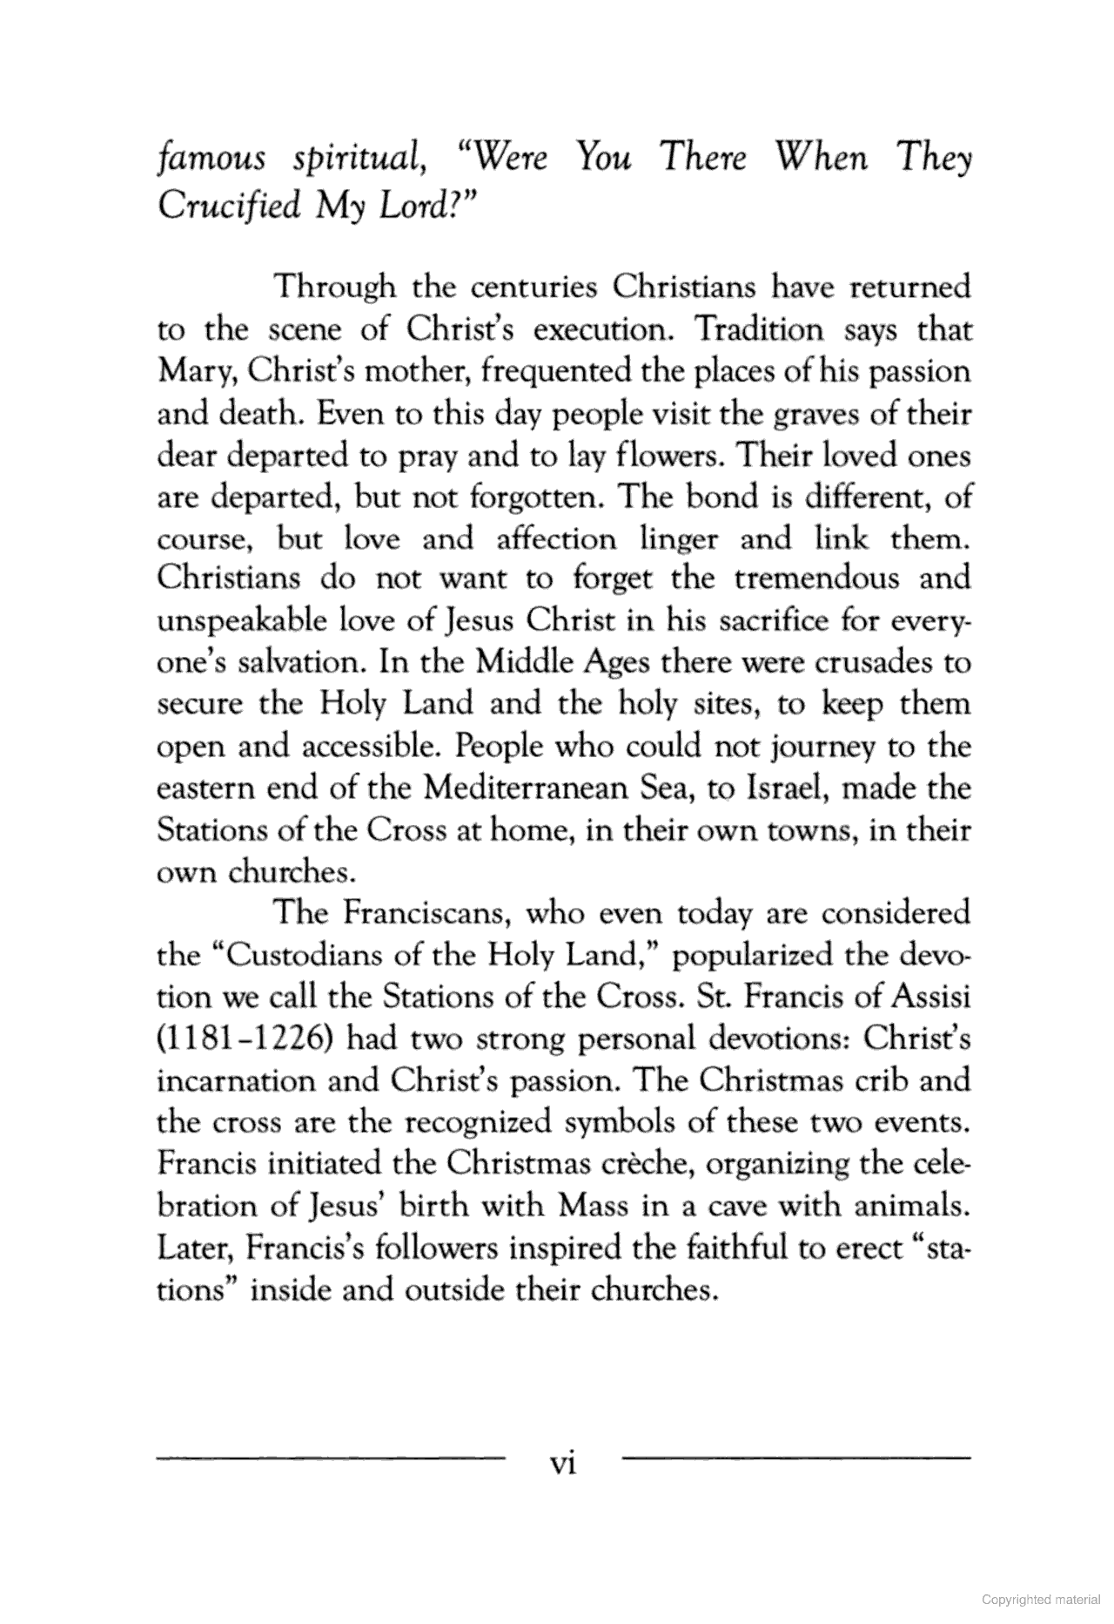



Contents

|  |  |  |  |  |  |  |  |  |  |
| --- | --- | --- | --- | --- | --- | --- | --- | --- | --- |
|  | [Books](https://books.google.co.uk/books?id=5L8AkvjbZNoC&lpg=PP1&pg=PR5) |  |  | |  |  | | --- | --- | | Buy this book |  | |  |  | [More about this book](https://books.google.co.uk/books?id=5L8AkvjbZNoC&hl=en) |

Loading...

Loading...

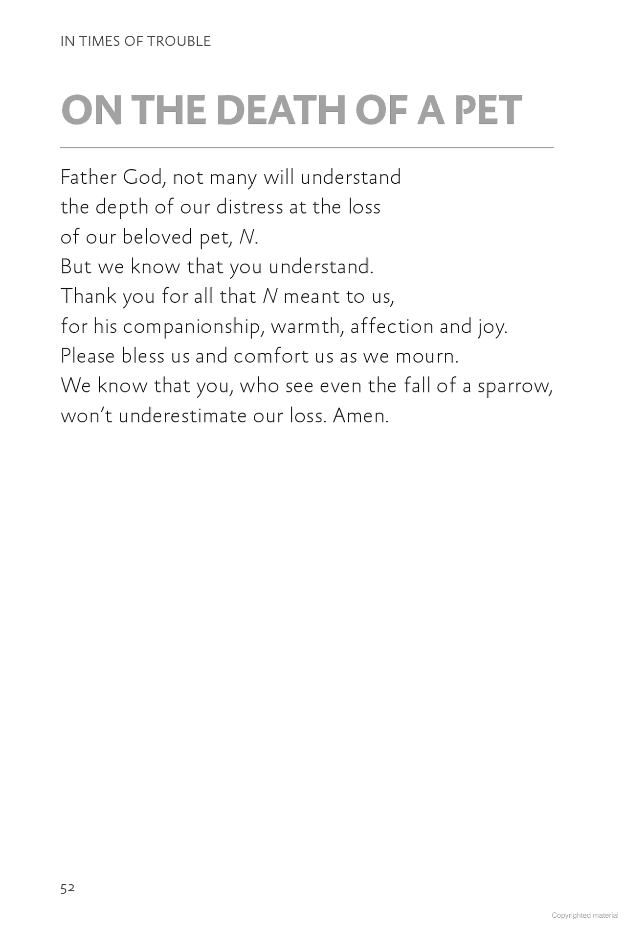

Loading...

Loading...



|  |  |
| --- | --- |
| |  | | --- | | Pages 54 to 56 are not shown in this preview. | |

Loading...

Loading...





Contents

|  |  |  |  |  |  |  |  |  |  |
| --- | --- | --- | --- | --- | --- | --- | --- | --- | --- |
|  | [Books](https://books.google.co.uk/books?id=AUTeAAAAQBAJ&lpg=PP1&pg=PA53) |  |  | |  |  | | --- | --- | | Buy this book |  | |  |  | [More about this book](https://books.google.co.uk/books?id=AUTeAAAAQBAJ&hl=en) |